Name=Mina Bohora

Roll no=5797

**Wireframe and Mockup**

1. **Design the below like wireframe structure. Use your own creativity.**

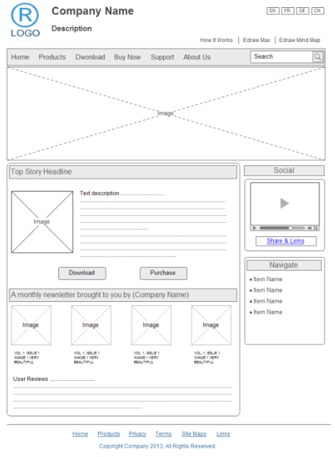

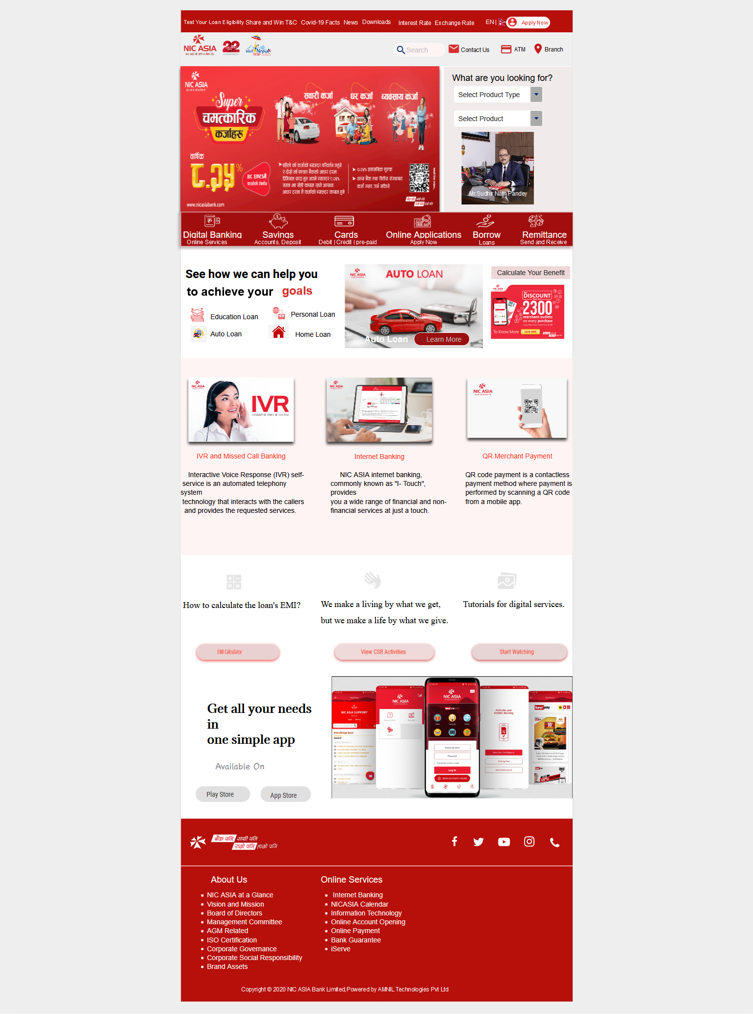

Link= <https://app.moqups.com/02YHZ5PTLJ/edit/page/a61028144>

2. **Create a mockup design like your college website’s contact us page. Use your own creativity for this design.**

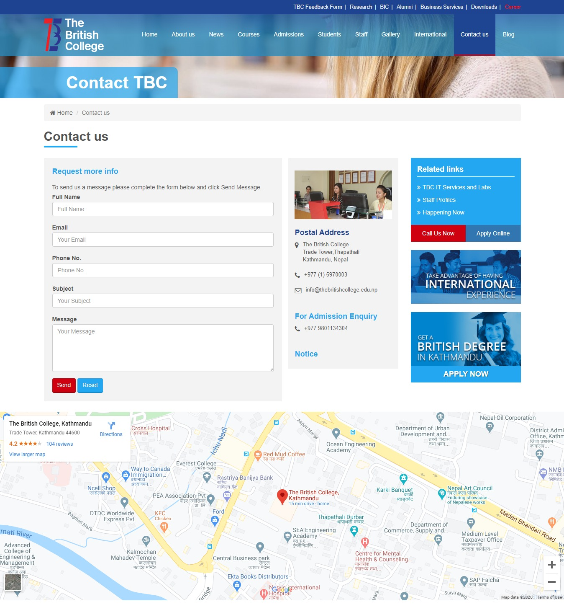

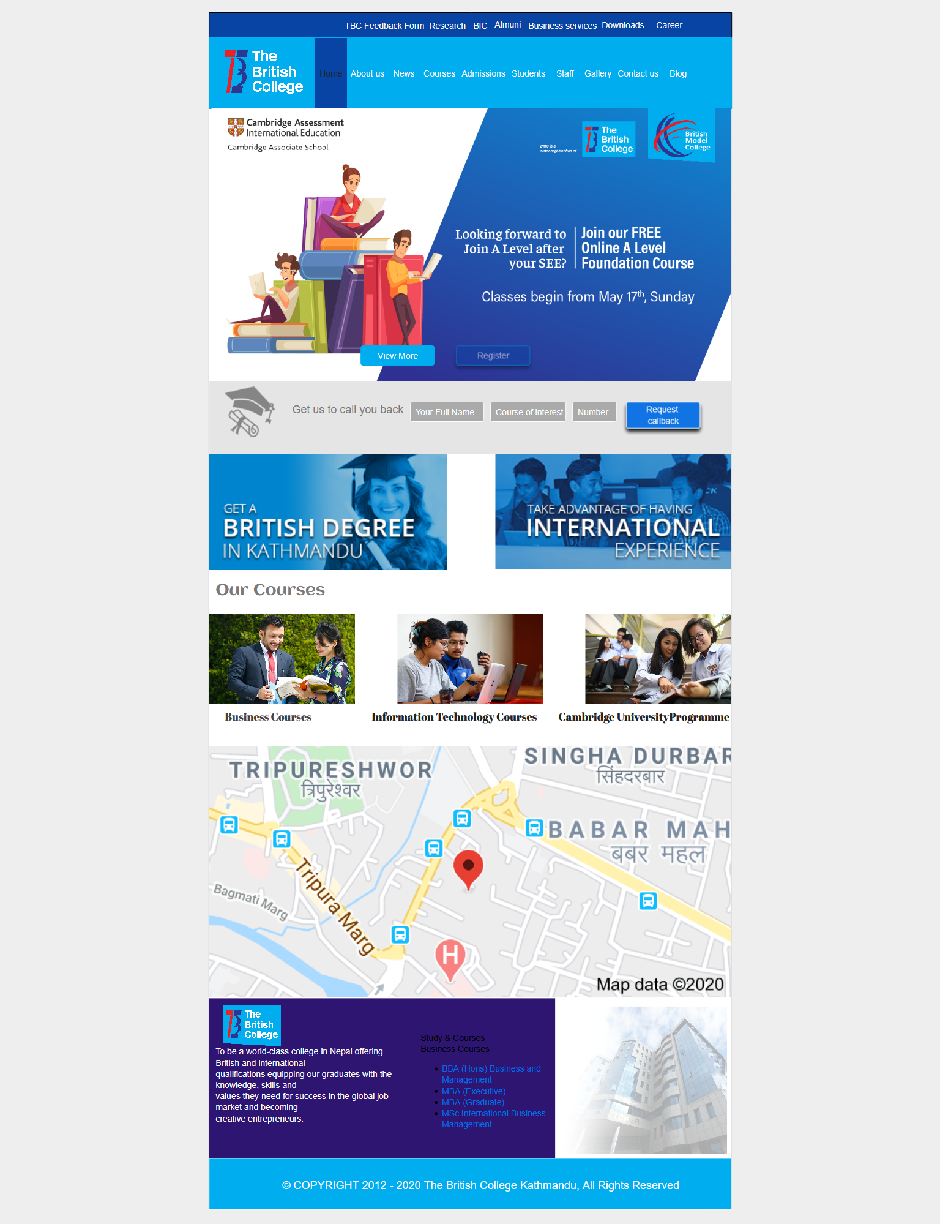

Link= <https://app.moqups.com/02YHZ5PTLJ/edit/page/a8479f1dd>

Practice

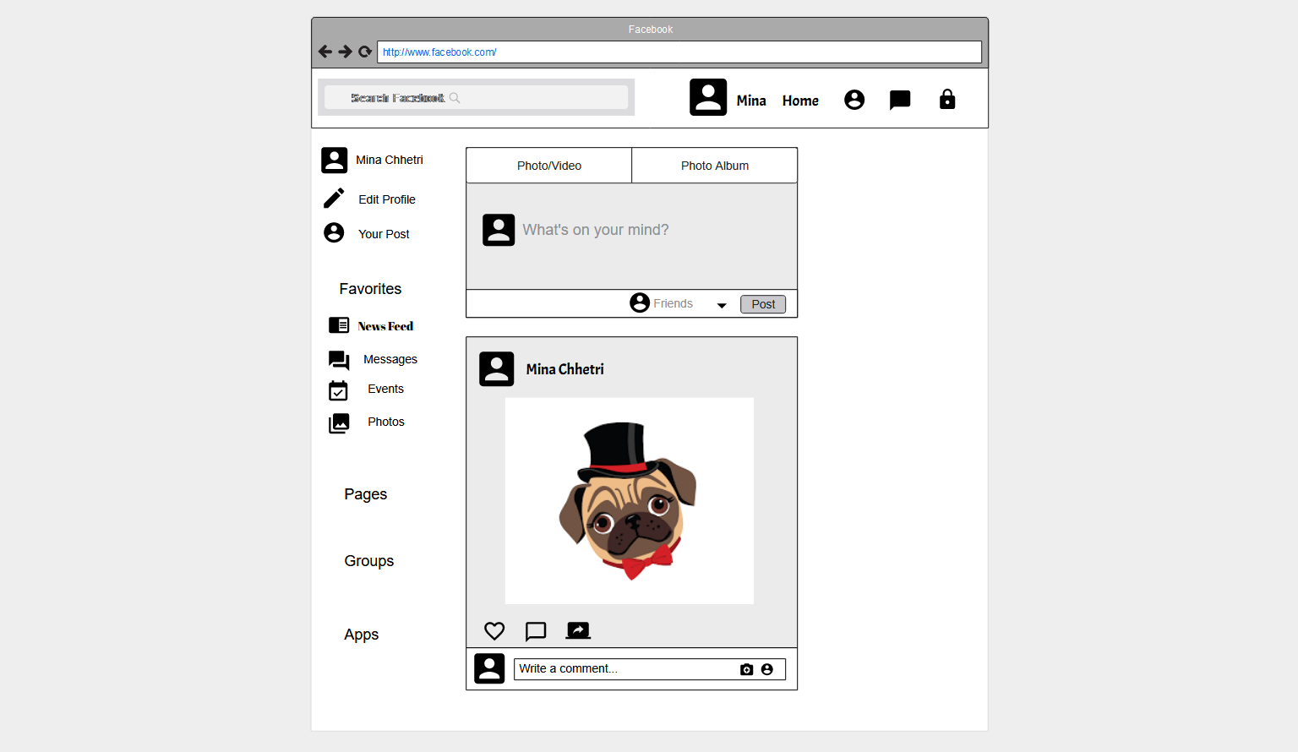

Link= <https://app.moqups.com/02YHZ5PTLJ/edit/page/a745fa7b8>